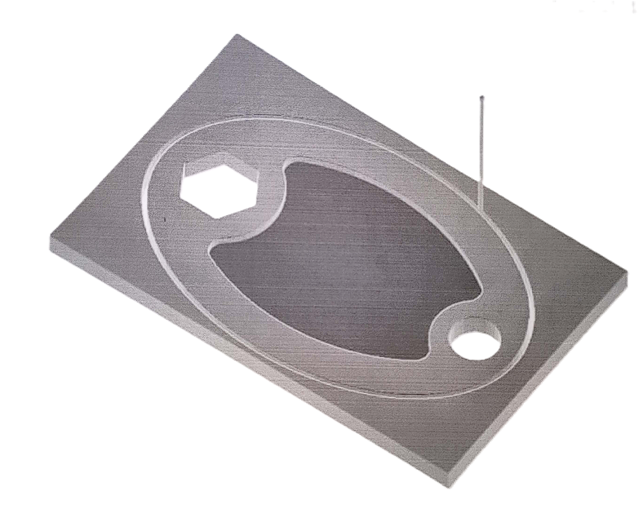
NAME: AKSHAY MARIGERI
USN: 2GI21ME404
SIGN:

